# CS4112/CS54111 INTRODUCTION TO DATA SCIENCE

# Exercise.1: Print out the all variables but hp column using the select function.

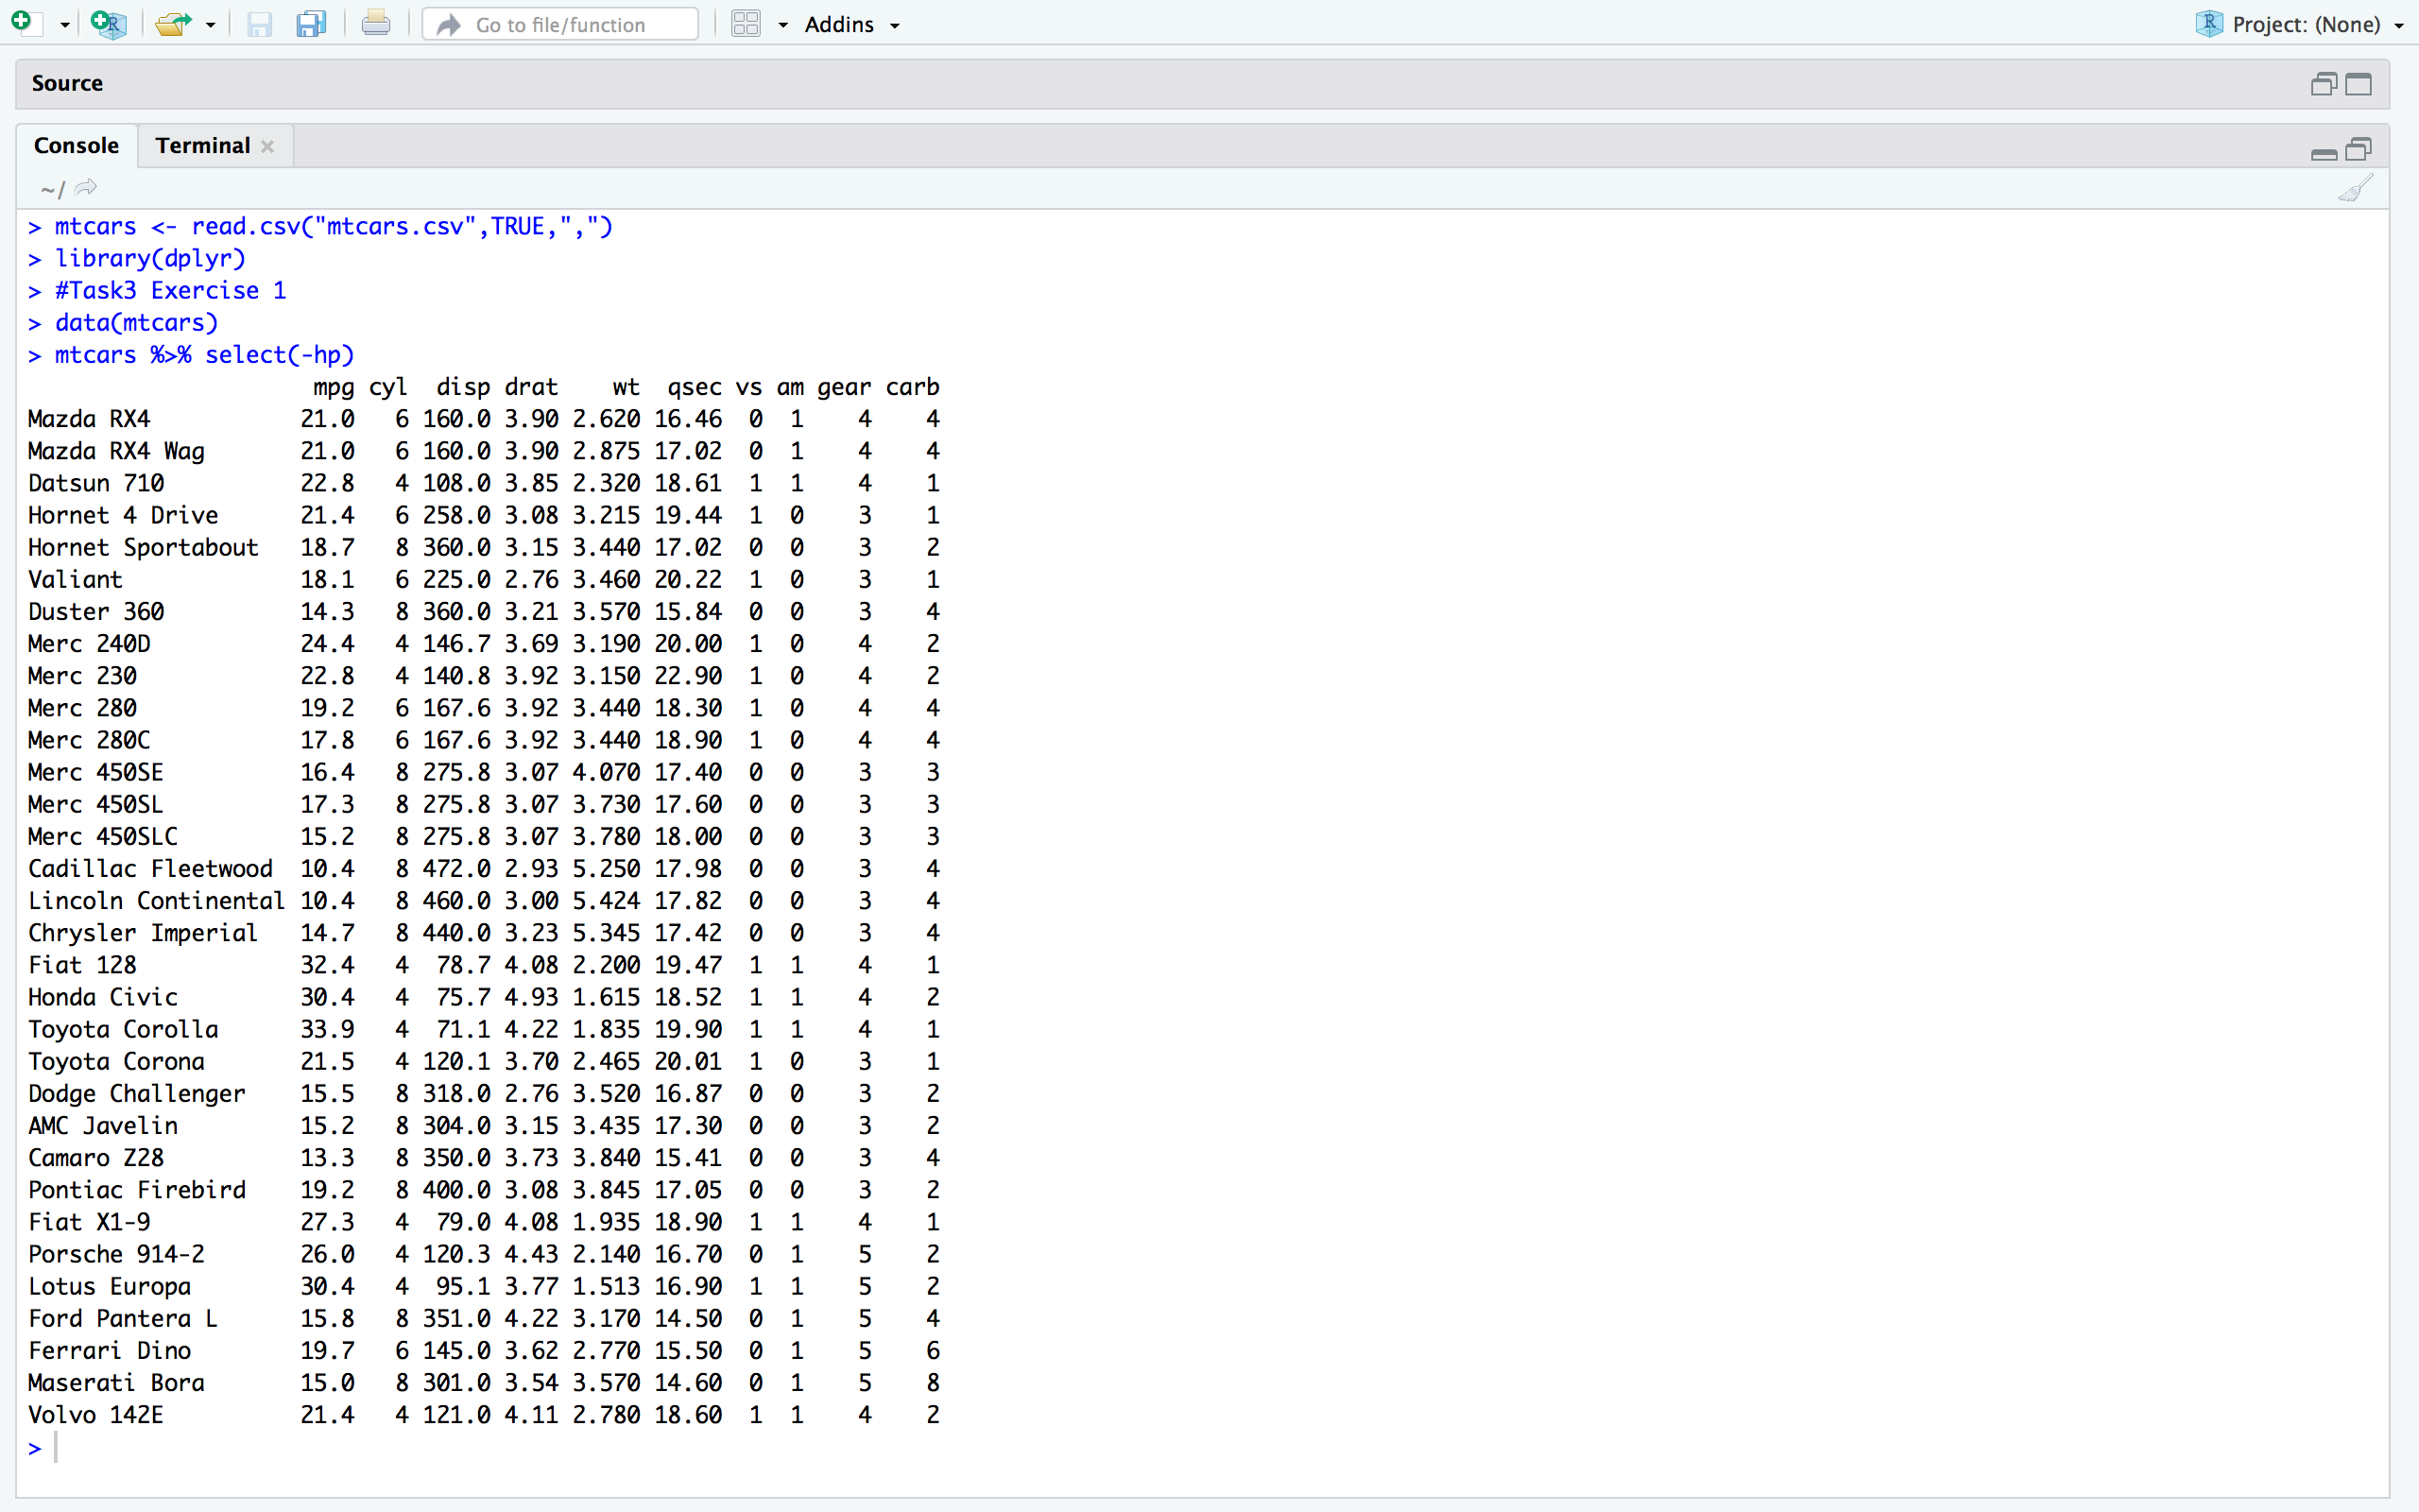

# Exercise.2:   Print out the mpg, hp, vs, am, gear columns.

# 

# Exercise.3:  Create the object cars_m_h containing the columns mpg, hp columns but let the column names be

# 

**Method 1 select function without pipe**

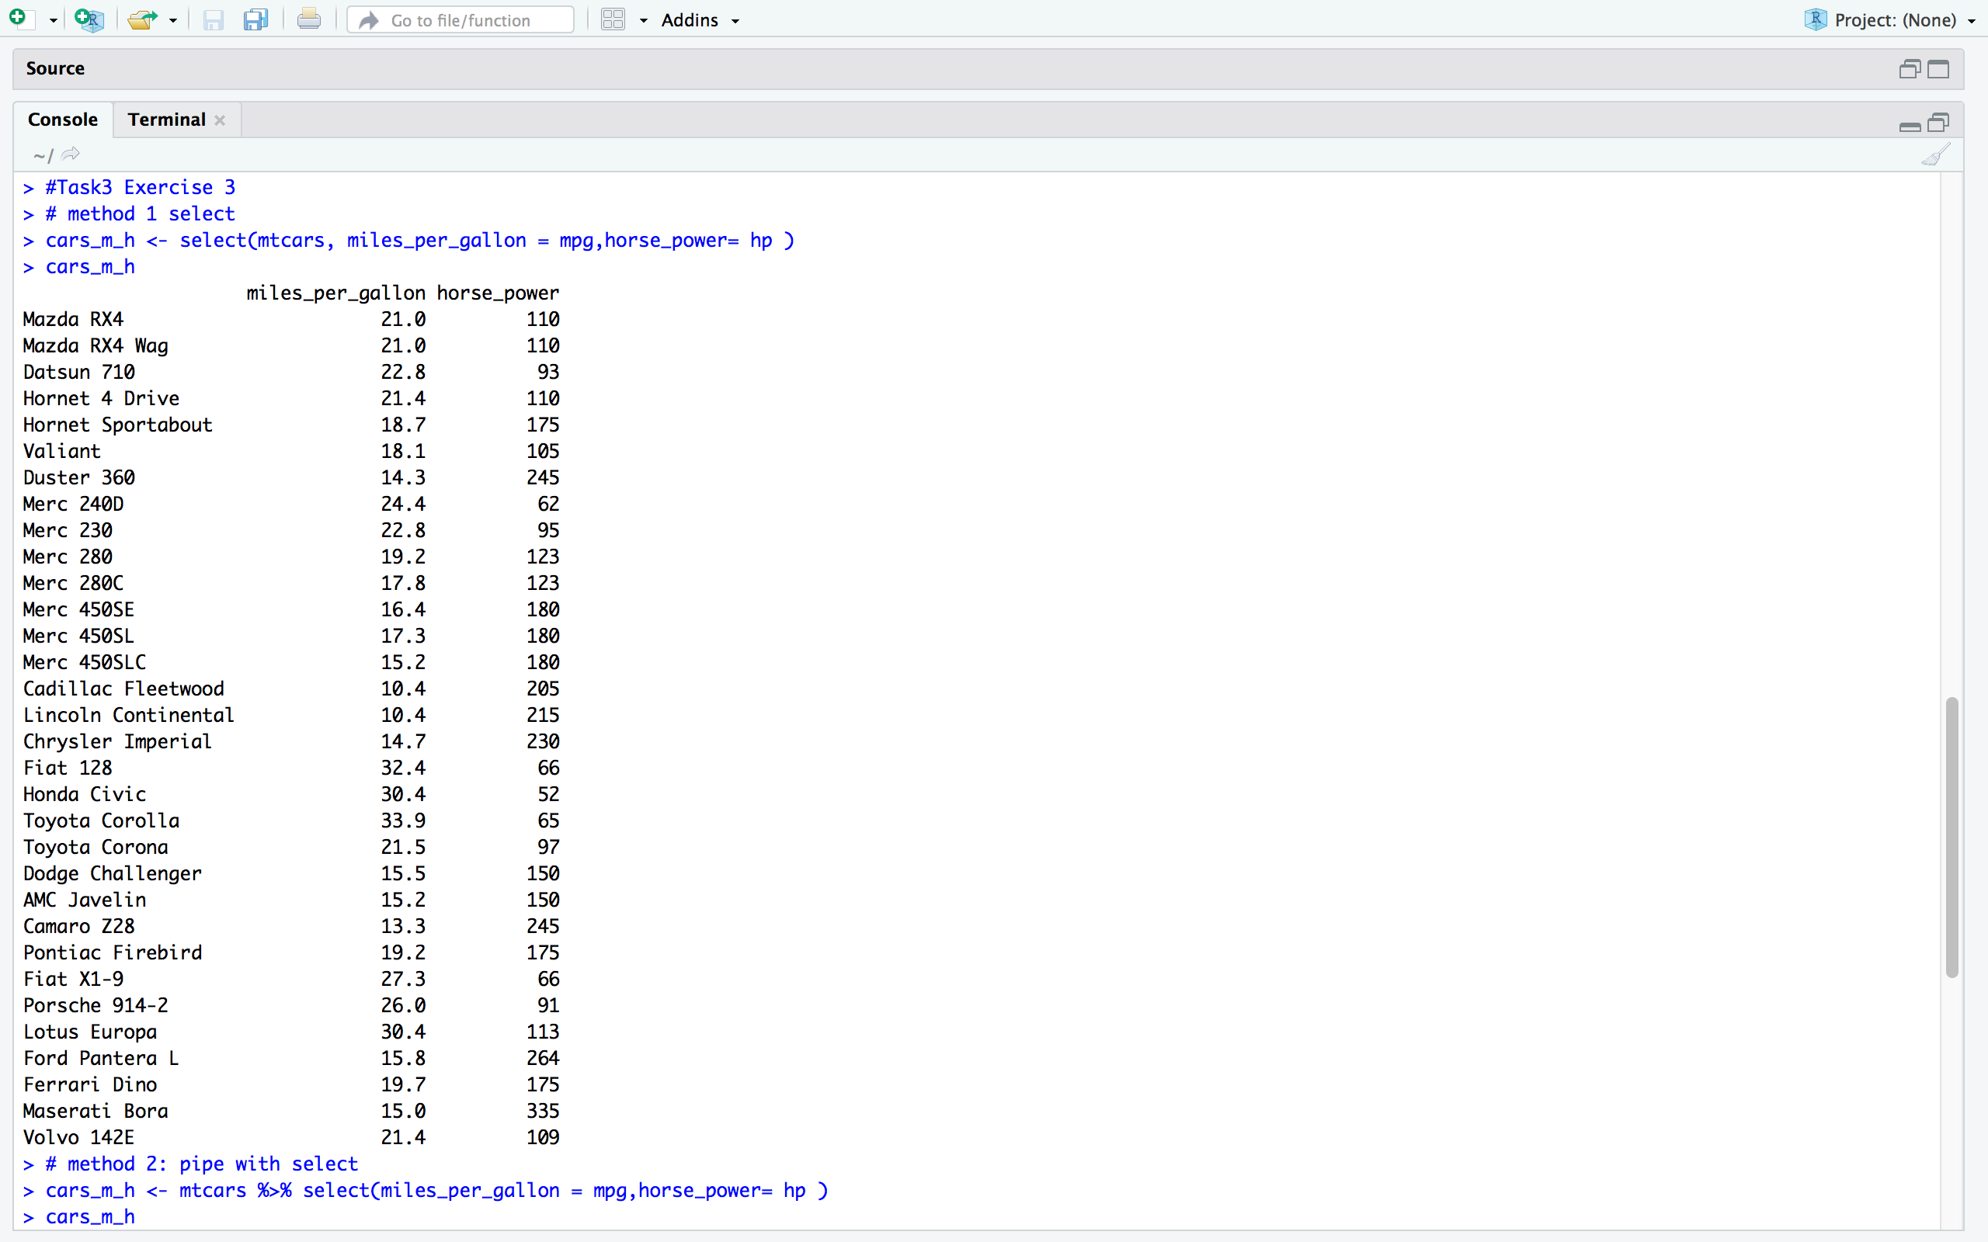

**Method 2 select function with pipe (%>%)**

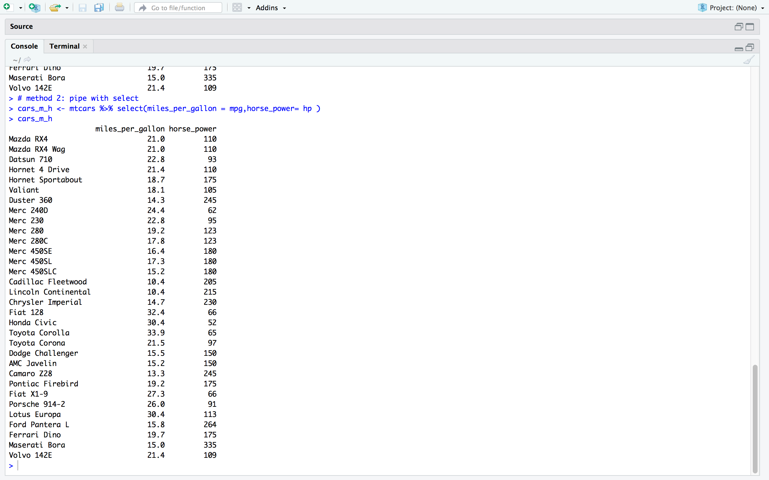

# Exercise.4: Change the column names of cars_m_h from ‘miles_per_gallon’, and ‘horse_power’ to ‘mpg’ and ‘hp’ respectively.

# 

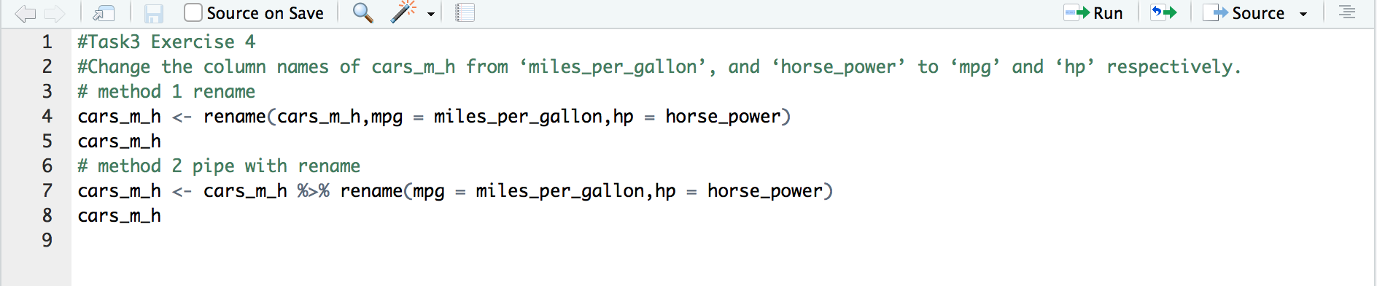

**Method 1 rename function without pipe**

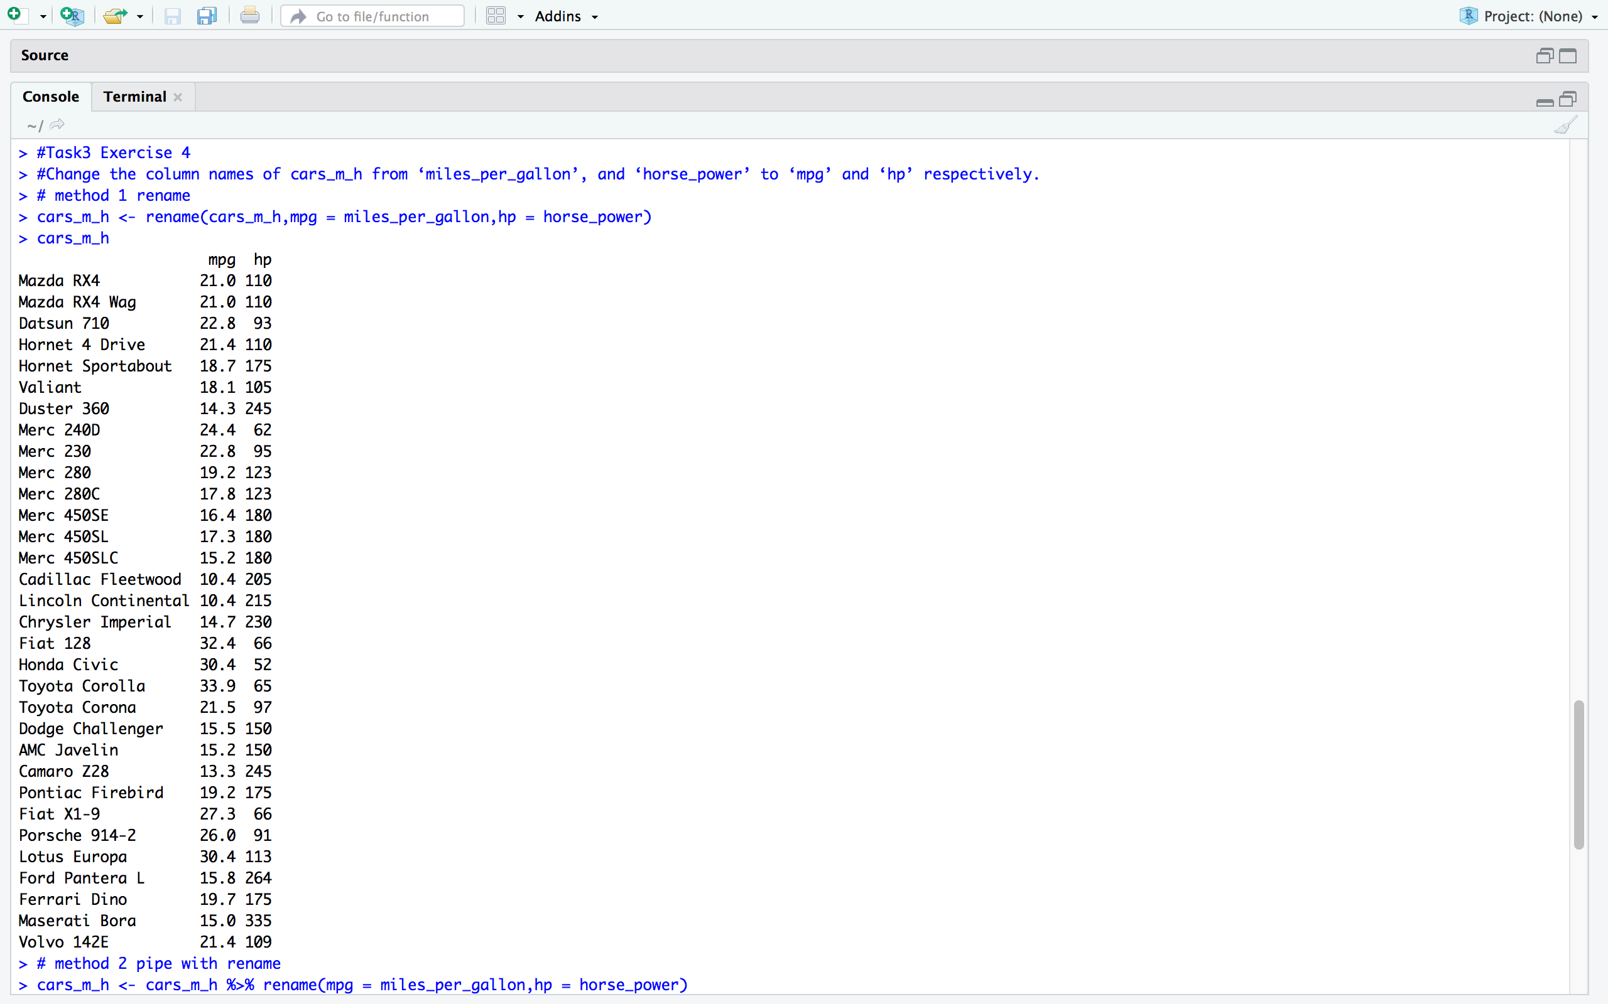

**Method 2 rename function with pipe (%>%)**

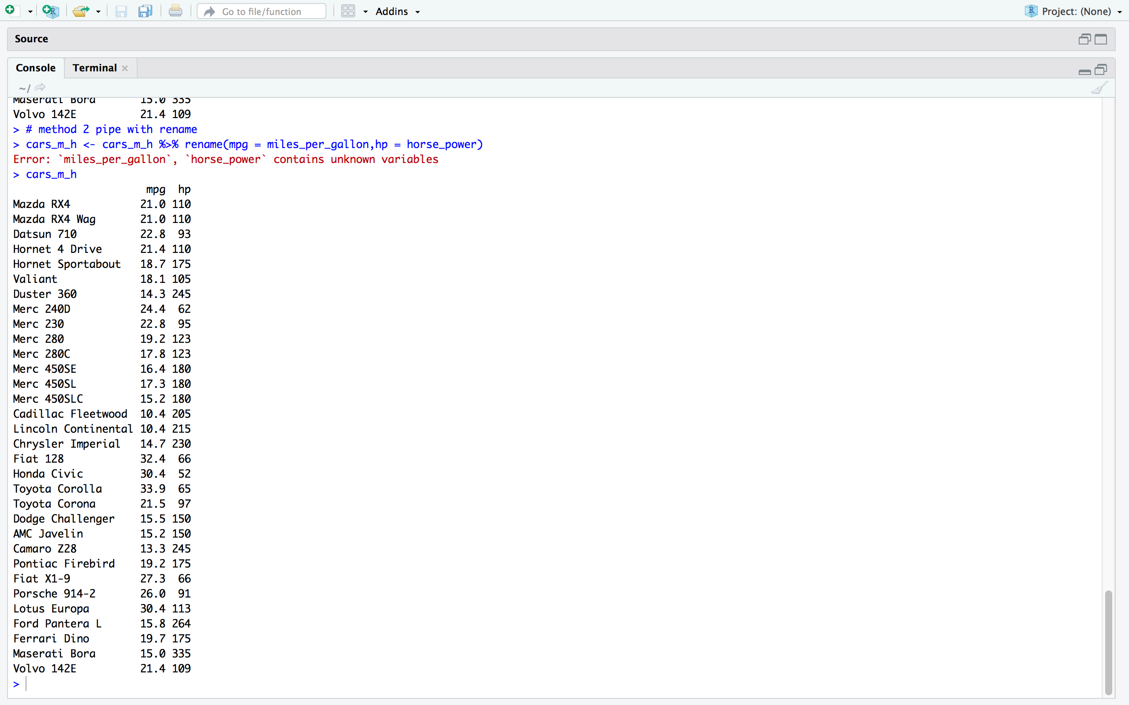

# Exercise.5 : Create a cars_m_h_s object, containing from 10th to 35th row of cars_m_h.

Code:

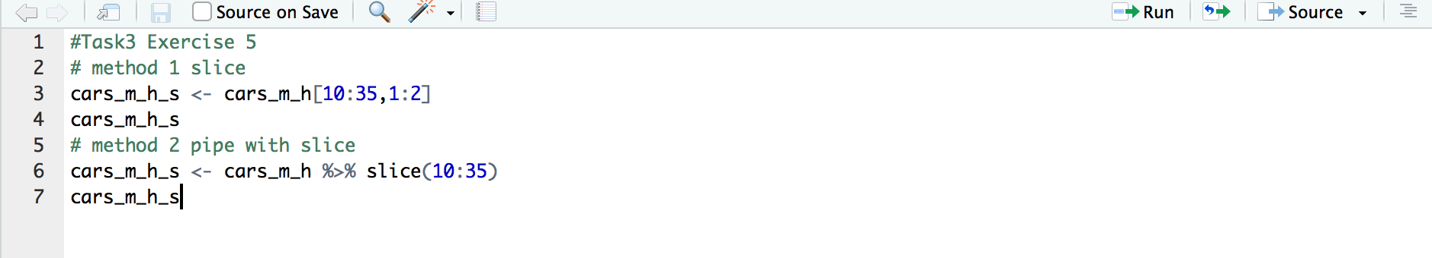

**Method 1 slice function without pipe:**

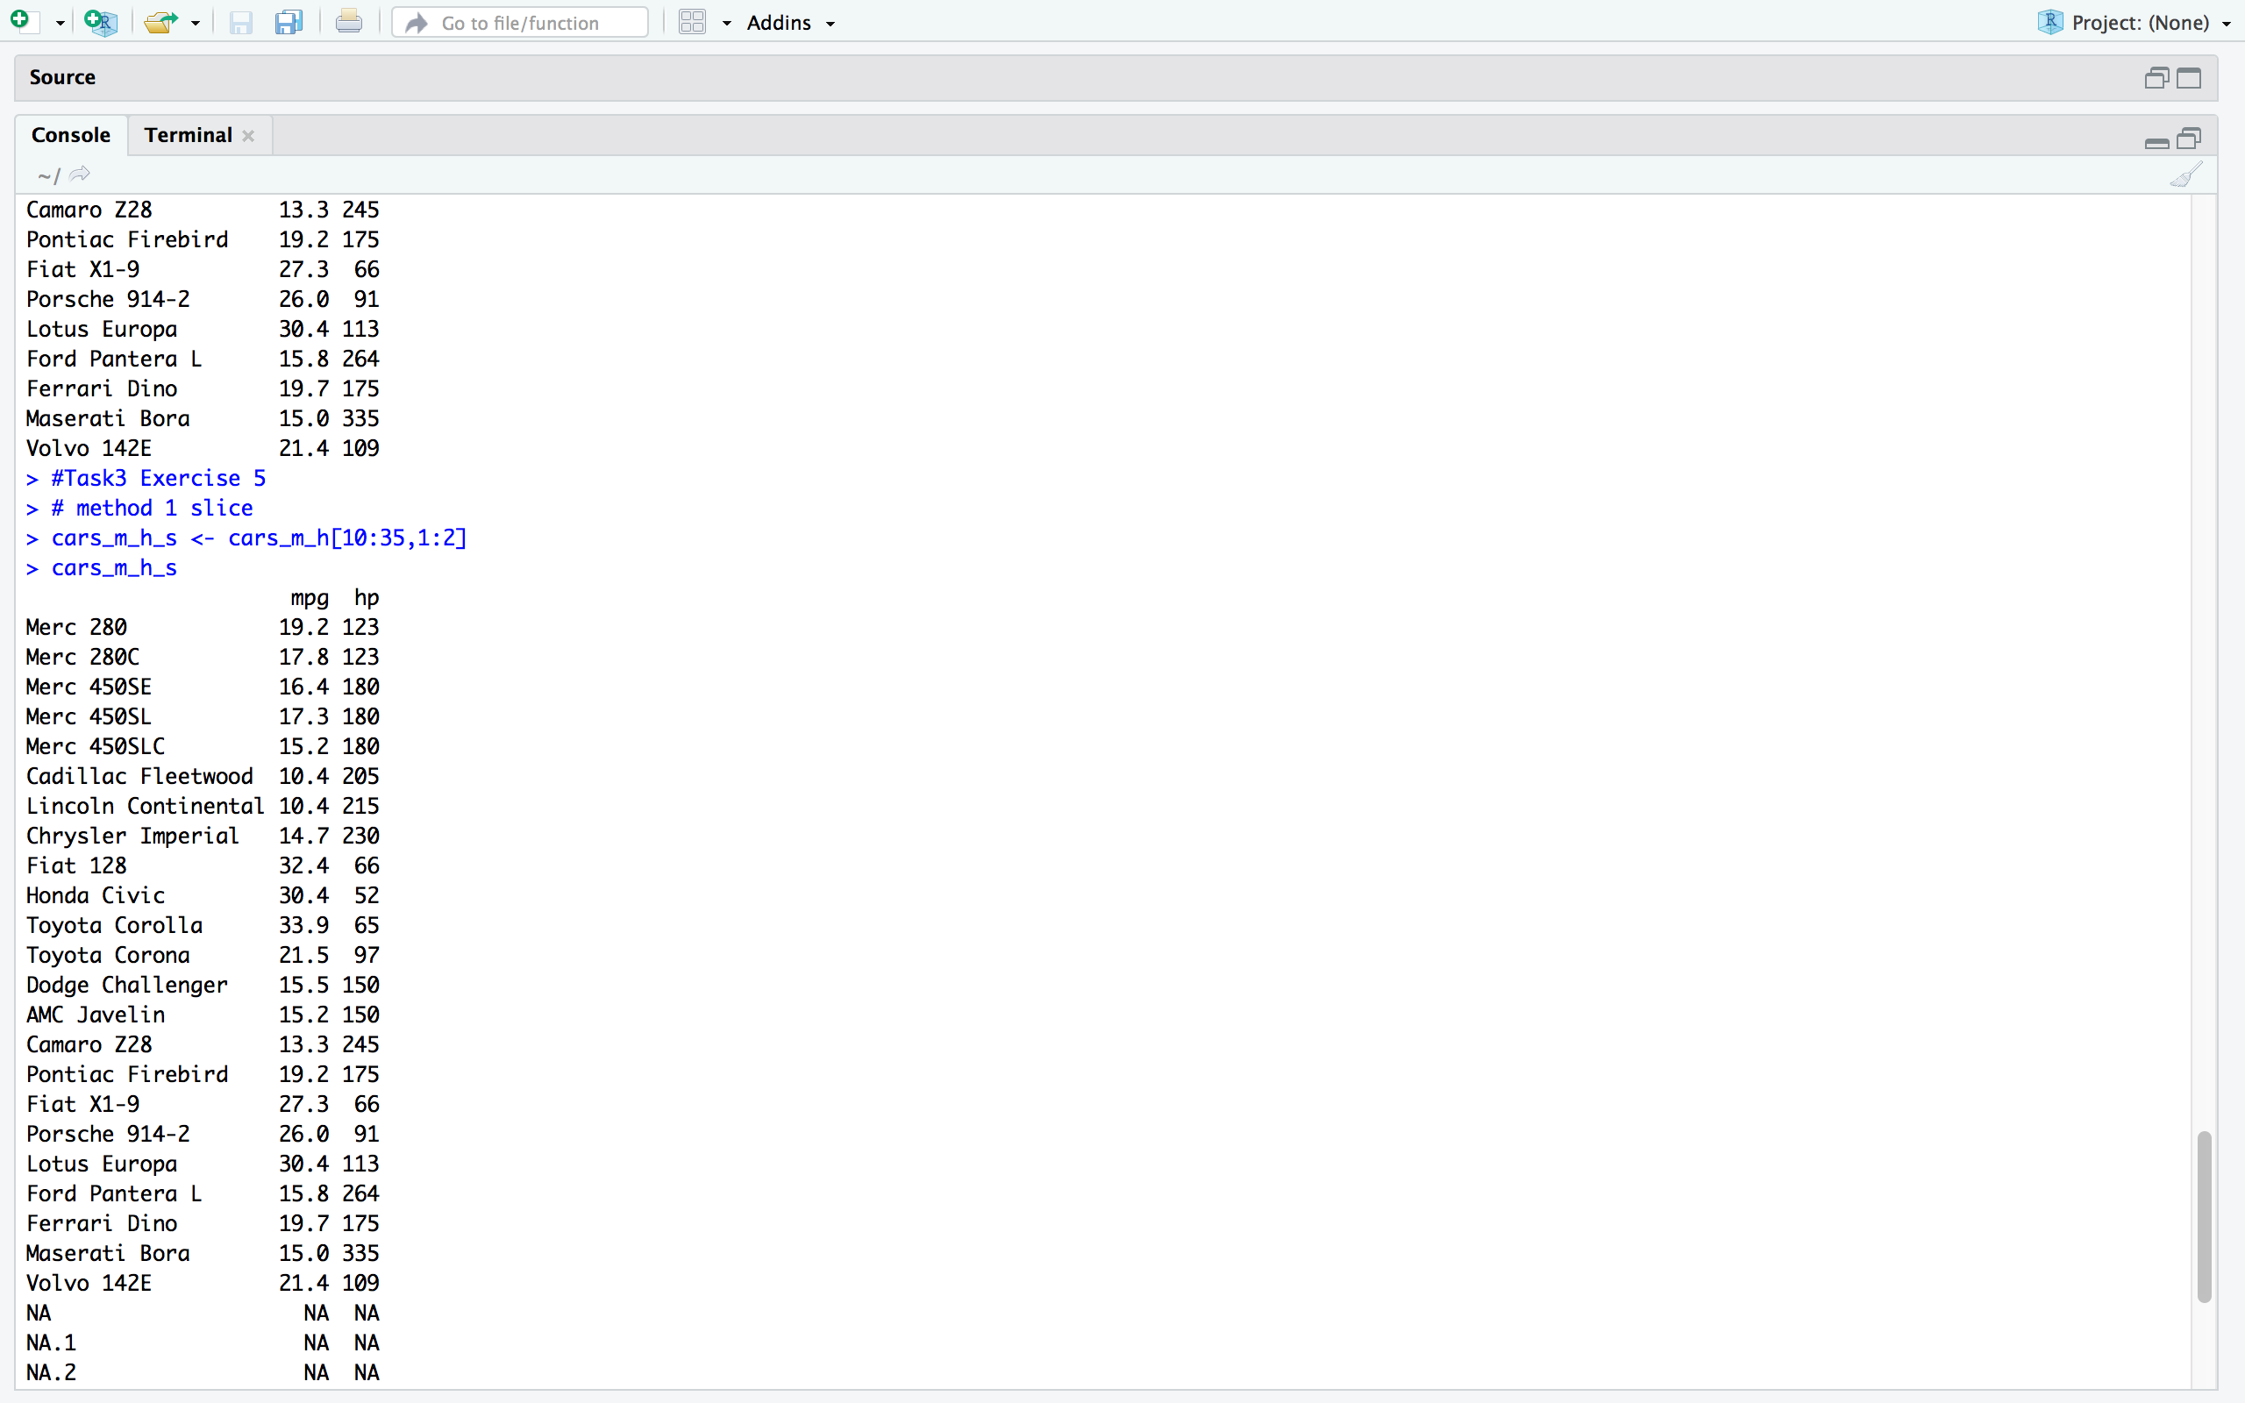

**Method 2 slice function with pipe (%>%):**

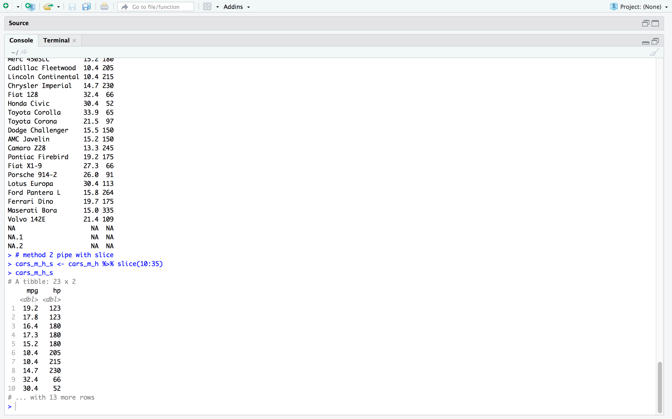

# Exercise.6:  Print out the cars_m_h_s object without any duplicates.

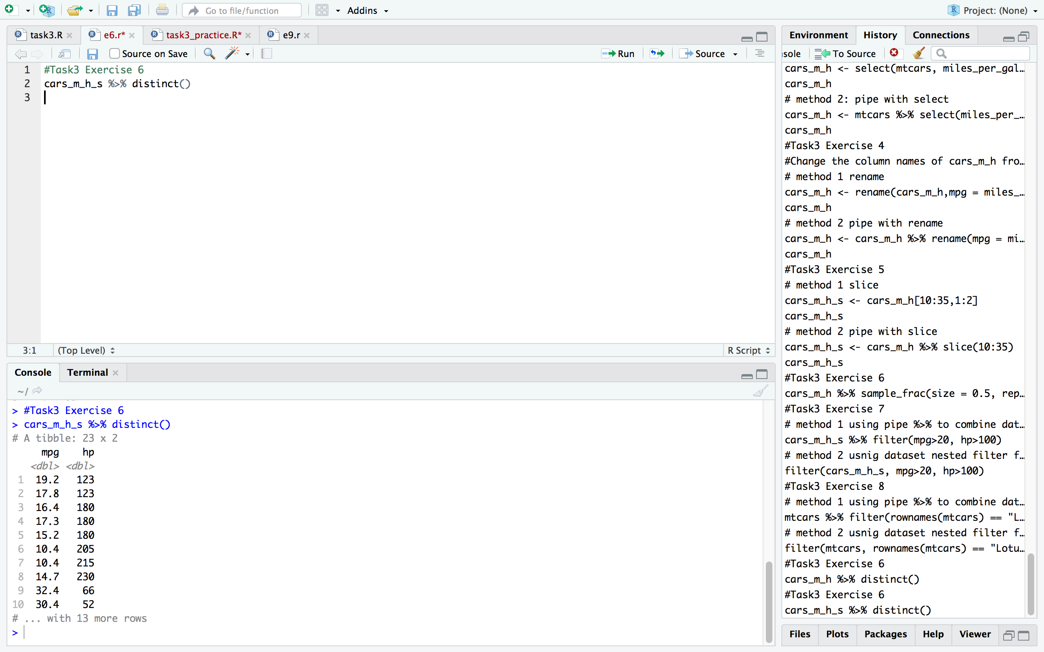

# Exercise.7:  Print out from cars_m_h_s object all the observations which have mpg>20 and hp>100.  (filter())

# 

# Exercise.8: Select the ‘Lotus Europa’ car.

**Here we use rownames() function to find out the data**

# 

# Exercise.9: You are required to use the data wrangling techniques that you learned to transform the currency data in a tidy way. You may convert all the Pounds into US Dollars.

1. Start-up code :

Packages should be installed : tidyverse (for tidy the data)

lucr ( for converting the currency)

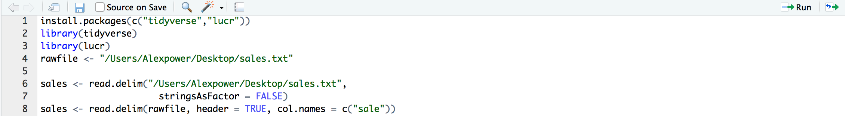

1. Make the GBP (Great British Pound)data in a tidy way:

tidy GBP part (by using: from_currency) and convert the British Pound to USD by multiplying 1.34, which is the currency rate between GBP and USD

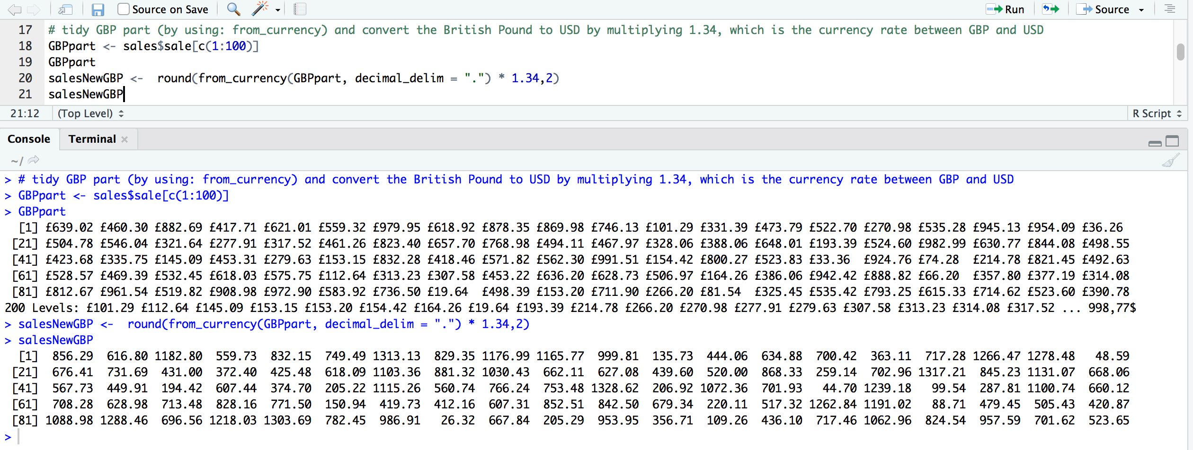

1. Make the USD data in a tidy way:

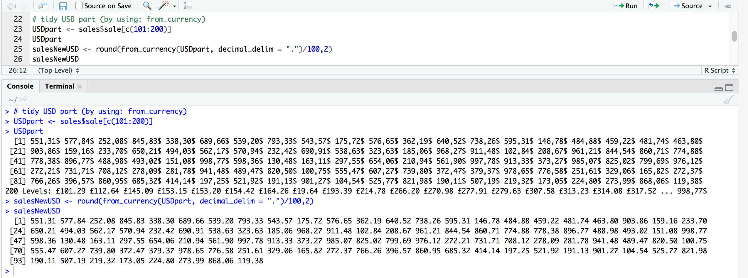

1. Combine two currencies data :

use: to_currency(), to transform the value from digits to currency value



 